Theme: Webinars See information to right on the wide variety of webinars being offered by IISE and other professional societies
______________________________
Chapter members are invited to set up a site tour of their employer’s facility for the chapter’s membership, in exchange for half off membership dues for a year. The tour ideally should include at least one topic of interest to IISEs, examples automation, just in time, lean, logistics, etc. The brief proposal should include the name of the employer, the location of the facility, the approximate size of the facility, a sentence or two about the focus of the proposed tour, any date or time suggestions and/or restrictions for the tour, and contact information for a contact person who can arrange such tour.

September Programs

September – Webinars!

Wednesday, Sep 9:
top 20 ISE Capstone Senior Design Projects for 2019-2020.
That will be a great way for you to see what our great ISE Students are doing with what they are learning in our ISE Departments.
Registration URL for the 9 September Webinar

https://attendee.gotowebinar.com/register/5727613762926672143

Wednesday, September 16:
Scott Cornish presents on the digital transformation and its impact on the quality profession. Topics will include:

- What is Digital Transformation?
- History
- Technology of Digital Transformation
- Industrial Internet of Things/Industry 4.0
- Big Data and Analytics
- Cloud Computing
- Artificial Intelligence/Machine Learning/Robotic Process Automation
- Virtual/Augmented Reality
- 3D Printing/Additive Manufacturing
- Cyber Security
- Maturity Indexes
- Other Predictions

To register for this event, please RSVP to SCornish@sections.asq.org.

President’s Message

Hello members!

I hope you have all been having a good summer in spite of Covid-19. I’m sure some of you, like me, had to make changes to plans you had, or even saw plans canceled altogether. I know I had planned to attend a couple car shows and even enter my motorcycle into one. Instead, one of the highlights of my summer has been weekly video calls with my family overseas.

Our chapter has also had to make changes. Our board meetings were moved to conference calls, which allowed us to easily exceed our goal of holding two remote meetings this year! For the time being, these meetings will continue to be remote, and as always remain open to members. While changing our meetings to remote went smoothly, adjusting our approach to monthly events was not as easy. After some debate, the board elected to postpone our annual ice-breaker event as we want to be sure that members would be comfortable with the idea of getting together in person. In the meantime, we will be shifting our monthly events to online based activities, so look out for those in our newsletters.

I hope you’re doing well and staying safe, and as always feel free to reach our with any questions or comments.

Regards,

Nicolas Le Gall

President – IISE chapter 132, IISESJDVPC

CAR Article

2020-2021 Future Cities Competition Updates
Like most everything else; the Future City Competition is adjusting for COVID and going on-line. This science competition for 7th & 8th graders; which in 2020 celebrated 25 years help students learn about science and engineering principles. The Philadelphia regional competition is still expected to take place in January. Our IISE Chapter has been supporting this competition since the beginning; with the very 1st regional champion hailing from Cherry Hill, NJ.

Future City uses the engineering design process as a framework to guide students through the creation of their cities. Within this framework, students apply specific project management methods to keep their projects on track. This structure gives students a real-world learning experience they can apply to future challenges in school, work and life.

This year’s theme …………. Living on the Moon.
Students spend approximately four months creating cities that exist at least 100 years in the future and represent the team’s solution to a citywide sustainability issue. The competition is made up of five project deliverables.

At Regionals, scores from all five components will be added together to determine the top team. The 1st place team in each region will advance to the Finals held in Washington, DC.

Future City has made several adaptations due to the COVID-19 pandemic and uncertainty surrounding the school year and extracurricular activities. Bookmark this page for continued important updates throughout the program cycle!

• Teams can complete the deliverables in-person (i.e. in a classroom or afterschool program) or remotely (i.e. collaborating online while learning from home).
• The competitions (regionals and Finals) will take place online, rather than in-person.

Updated Deliverables
Virtual City Slideshow: No longer a required deliverable. Teams can use SimCity as an educational tool (codes will be provided) but nothing is submitted or scored.

City Essay: No change! Design a lunar city and provide examples of how your city uses two Moon resources to keep your citizens safe and healthy.
• 58 points

City Model: Teams build a physical model of their future city (to scale) using recycled materials.
• Teams may create a single model OR multiple model segments.
• Then using the provided template, teams will submit a PDF slideshow containing photos and accompanying descriptions of their model prior to the Regional Competition.
• 65 points

City Video Presentation: Teams record a 7-minute video presentation about their city.
• The recorded video is due prior to the virtual Regional Competition and the question-and-answer session will be separate (see below).
• Rubric is based on presentation content rather than video production.
• 50 points

City Q&A:
• No longer part of the City Presentation, the City Q&A has its own rubric this year.
• In order to maintain the interaction between students and professionals that makes Future City so special, teams will have an expanded 10-minute question-and-answer session with judges from the engineering, technical, and city design fields.
• Sessions will be conducted live via a video conferencing platform and scheduled by your Regional Coordinator.
• 25 points

Project Plan: No change! Teams complete a project plan to help them plan and organize their project.
• 10 points

CHAPTER NEWS

Event Report
No live events were held during the summer, but there continues to be a lot of activity online and in select operations throughout the area. If you have a story to tell on you or some individual/company that you know of that you would like to share, please email the newsletter editor at kdrevik@yahoo.com.

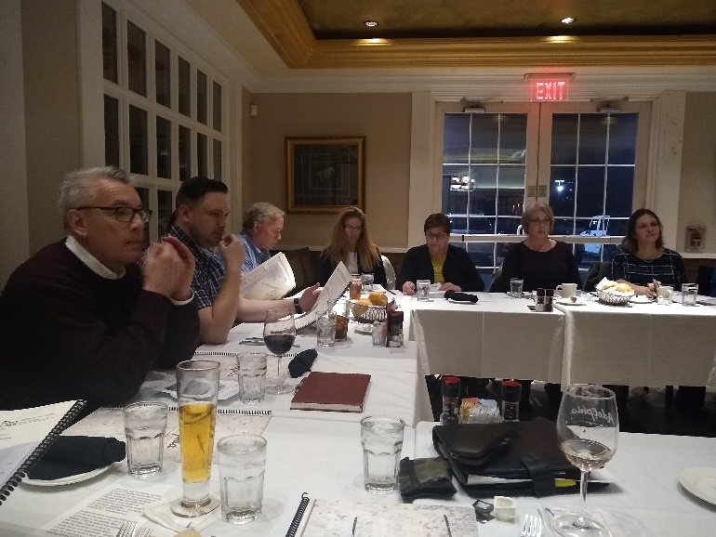

Member News? – Contact the Newsletter Editor with any news you would like to share.

About Our Next Meeting

TBD, based on current state of quarantine in NJ, DE and PA

Delaware Valley Senior
Chapter No. 132 Officers & Directors

Nic Le Gall
President
nic.legall@gmail.com

Carrie Weber
Vice President
(W) 215-495-7439
carrieannaweber@gmail.com
Paul Siebeneicher
Secretary, Director of Internet Communications &
Web Site Master
paulsehnen@yahoo.com
(C) 856-630-5564

Rick Huysie
Treasurer
(H) 856-931-7352

John McGowan, PE
Director of CPP Report & Engineer’s Week -
(H) 856-722-4593, (F) 856-722-7768
john.p.mcgowan@lmco.com

Kevin Drevik
Director of Communications/Newsletter and Programs
(C) 856-630-2485
KDREVIK@yahoo.com

Fred Rexon
Director of Membership
(W) 856-428-7400, (F) 856-428-1270
fredrexon@precisionautomationinc.com

Frank DeFelice
Director at Large
fd744@aol.com

Marven Chin
Director at Large
Mmchin8893@comcast.net

Career Development

IIE EVENTS & TRAINING

- JulSeptember

Sep 14: Intro to IE in Healthcare (Norcross, GA)

Sep 15: Six Sigma Green Belt Process Improvement Livestream (Los Angeles CA)

Sep 21: Lean Green Belt Livestream (Norcross, GA)

Sep 22: Six Sigma Black Belt Livestream (Los Angeles CA)

Sep 28: Six Sigma Green Belt Livestream (Norcross, GA)

Sep 28: Healthcare Labor Management (Norcross GA)

- October

Oct 1: From Engineer to Leader (Norcross, GA)

CAREER CENTER

South Jersey Delaware Valley Chapter Employment Assistance Network
Are You Looking For A Job? Do You Know Of A Job Opportunity?
Contact The SJC Employment Assistance Network: Email your name or any hot opportunities to Kevin Drevik at Kdrevik@aol.com

Adjunct Professor Position at Temple University
The Industrial & Systems Engineering program within the Department of Engineering, Management and Technology at Temple University, is seeking adjuncts in Philadelphia PA. To be considered, candidates should minimally possess a M.S. in either Industrial or Systems Engineering (or a closely related field) and have excellent communication skills. Applicants with relevant industrial/professional experience are encouraged to apply. The successful candidates will be expected to teach courses leading to the B.S. in Industrial & Systems Engineering and demonstrate a strong commitment to student success. Long term potential exists for full-time employment.

To apply or for more information, send a cover letter and resume to: ntt-ise@temple.edu

Potential course topics:
Spring 2021
• Product QA
• Stochastic models in OR
• Production Planning & control

2021-22
• Simulation
• Facility Planning
• Systems Eng Fundamentals
• Production Process Design

Principal Supplier Quality Engineer

BAE Systems

Mount Laurel, NJ 08054

We are looking for an experienced Supplier Quality Professional to implement tools and processes to ensure suppliers are prepared and have robust plans to meet product quality requirements for BAE Systems program customers. The person will investigate, evaluate, and resolve supplier quality problems by conducting audits, analyzing defect trends, and leading continuous improvement projects. This position requires an independent, self-motivated and self-directed professional to address all regional Supplier Quality needs in the North East Region that includes but not limited to PA

Expected Travel requirement: Approximately 50%, with peaks of activity exceeding 75%. This will be a mix of local, day visits as well as some overnight travel, outside the local area.

The ideal candidate will:
- Utilize supplier Scorecards/metrics and analytical tools to quantify performance levels of individual suppliers and work with those suppliers to develop improvement plans to achieve quality performance goals.
- Evaluate the impact of non-conforming product and assess suppliers' corrective action robustness in order to ensure strong and permanent countermeasures.
- Champion problem solving and Root Cause analysis activities with suppliers to eliminate recurrence of non-conformances and drive "Zero Defect" mentality within the supply base.
- Perform Source Inspection of product at supplier locations.
- Perform and Evaluate First Article Inspections per the requirements of AS9102 as well as train suppliers to meet BAE System's expectations.
www.indeed.com

Industrial Engineer, Level I

Burlington Stores

Edgewater Park, NJ 08010

As an Industrial Engineer on our growing supply chain team, you will help to improve processes and productivity by providing changes to operations, work measurements, methods, materials usage, and training. Candidates must be willing to work a split schedule – 10-7pm or 11-8pm.

Responsibilities:
- Develop and maintain accurate and effective engineering standards through time and frequency studies conducted in the facilities.
- Provide documentation and conduct audits of “Best Methods” for all job functions including training of the hourly workforce on productivity and work methods.
- Analyze, implement, document, and conduct audits of enhancements to existing work methods, flows, and processes to increase throughput in the DC.
- Conduct analysis and cost justification for potential capital project requests.
- Identify, propose, and develop improved operational reporting.

www.indeed.com

Treasurer’s Report
Mr. Richard T. Huysie reports a Treasury Balance of $6,870.29 as of August 1, 2020 for the IISE South Jersey Delaware Valley Senior Chapter No. 132.

Membership Report

As of 8/19/2020 the SJDV Chapter has 97Members.
We had two members who have passes away in 2020 and they have finally been removed from the rolls.

Please Don’t Go! Time to renew your membership
Ellen Bass
Tom Masapollo
Seyedkian Seyed

Don’t forget to renew your IIE Membership!

Your support of your professional society is greatly appreciated. We value your Membership!

Did you know …
The IIE South Jersey Delaware Valley Chapter will reimburse 50% of Member’s Dues if he/she recruits a new full-dues paying member? Please contact the membership director prior to your associate’s joining of IIE.

Did you know …
The IIE South Jersey Delaware Valley Chapter will reimburse 50% of Member’s Dues if he/she sets up a site tour of their company’s facility for chapter members to attend? Please contact the membership or newsletter director for more information.

Check out our Chapter’s Website!!

http://paulsehnen.wixsite.com/iisesjdvpc

Quote for Today: ““No person has the power to have everything they want, but it is in their power not to want what they don’t have, and to cheerfully put to good use what they do have.” Seneca
IIE-SJC Newsletter Advertising Rates

Ad Size Run Length Cost Full Year
1/8 Page Single Issue $20 $100
¼ Page Single Issue $25 $250 ½ Page Single Issue $75 $400
¾ Page Single Issue $75 $450
1 Page Single Issue $100 $500

Our sincere thanks to our Classified Advertisers for their strong Chapter support! Please patronize them
during the year!

Kevin Drevik
Newsletter Editor
South Jersey Delaware Valley Chapter No. 132
IISE, Incorporated
20 Crider Avenue
Moorestown NJ 08057

