Theme: New Technology

Date: Thursday, Jan 16th

Time: 5:30pm Networking
6:00pm Presentation
7:00pm Dining

Location: Adelphia Restaurant
1750 Clements Bridge Rd, Deptford Township, NJ 08096

Cost: $25.00 / Person

RSVP Sharry Masarek
smasarek@sections.asq.org

______________________________

January’s Program

Joint Meeting with ASQ on Waste Water Treatment in Current Environment

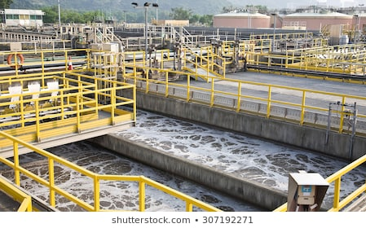

Dennis Palmer, the Executive Director and Chief Engineer of the Landis Sewage Authority, will be presenting on how he is working to make the wastewater treatment plant in Vineland into a zero-carbon footprint facility while providing its customers with high quality drinking water and maintaining the LSA's 1,800 acres of land as a natural habitat for a wide variety of insects, birds, and pollinators, including Monarch butterflies and bobwhite quails.
President’s Message

I’d like to open my first newsletter as President of this chapter by wishing you all Happy Holidays and a Happy New Year!
My name is Nicolas Le Gall and I will be assuming the role of President of our chapter for 2020. It is a great honor and I hope to live up to the high bar set by our previous presidents. Our outgoing President, Carrie Weber, first invited me to join a chapter meeting in 2016, and shortly thereafter, I joined because I saw that IISE provides people in our field with the ability to interact with each other, learn from each other, and do something farther reaching than what we might be able to in our day to day jobs and lives. As an Operations Analyst in an automated warehouse, following my undergraduate studies in Mechanical Engineering and Physics, our chapter provided me the opportunity to learn more about different aspects of our field from all of you. As a result of my interactions with you all and my interest in the field, I started and - as of December 2019 - completed a Master’s degree in Industrial and Systems Engineering at Rutgers University. I am looking forward to this new chapter in my career and my affiliation with IISE!
As we think about what we want to accomplish for our chapter in 2020, we want to give you the opportunity to attend some meetings via digital conferencing so that the board can elicit more direct feedback from you without imposing on your schedules. Additionally, one of the projects I am hoping to complete is to increase our membership through the expansion of our connections to regional universities. This will allow us to invite soon-to-be graduates to join our chapter to foster their interest in Industrial Engineering as they take their next steps.
I look forward to working with you and serving you in 2020.
Best regards,
Nicolas Le Gall – President, IISE Chapter 132

CAR Article

Don’t Look Now but The Future Is Coming!!! It’s Bright!
The Future City® Competition is a hands-on, real-world learning experience for middle school students to learn how engineers shape the world we live in today and tomorrow. Last year, Future City Philadelphia introduced over 600 middle school students at over 50 schools to the engineering profession. 49% of Future City participants are girls. 33% of participating schools enroll at least 50% of students in a free lunch program. The Philadelphia Region is celebrating their 25th competition. Our IISE Chapter has participated in 23 of them.
The Future City Competition is an excellent STEM program that is nationally recognized. Over the past few years, the Future City Competition has won three national STEM program awards: US2020 STEM Mentoring Award for Most Innovative Hands-On Project (2017), Henry C. Turner Prize for Innovation in Construction (2016), and the UL (Underwriters Laboratories Inc.) Innovative Education Award Grand Prize Winner (2015).
Middle School teams are tasked with developing a computer similar of a (their) city, a physical model, and an essay paper about their city. This Year’s Essay Challenge: “Clean Water: Tap Into Tomorrow” where they are tasked to choose a threat to their city’s water supply and design a resilient system to maintain a reliable supply of clean drinking water.
This year’s Philadelphia Region Competition will be held on January 18, 2020 at Archbishop Carroll High School in Radnor, Pa. Our chapter has provided funding and volunteers each year since 1996. This year we will again be sponsoring the P. Robert Siebeneicher Industrial Engineering Award; this is a special award given to the school that designs a city with industrial engineering considerations/principles regarding transportation, manufacturing basis, services, or other issues. As always, they need many volunteer engineers to mentor the schools, judge and to keep things moving smoothly on Competition Day. I encourage you to volunteer for the competition. Volunteers will need to sign up online at www.futurecityphilly.org . If you would like to be a special award judge and judge our chapter award; please let me know (john.p.mcgowan@lmco.com). The time commitment is 8:00 AM to 12:00 PM on the day of the competition (1/18/2020).
Questions?
• Contact John McGowan IISE CAR Director john.p.mcgowan@lmco.com
• Contact Susan Best, Sponsorship Coordination at susanbest54@gmail.com
• Visit our website: www.futurecityphilly.org , http://futurecityphilly.org/Sponsorship.html
Happy Holidays!!!! And Best Wishes for the New Year!!!! - JPM
CHAPTER NEWS

Event Report

On December 10th, the chapter joined members of the Philadelphia Engineering Society at their annual December event in downtown Philadelphia.

The topic of discussion was building resilience in an operation (not matter what type) and how it has gone from a feature to a requirement. A lot of discussion on weather events (like Sandy or some of the recent heavy snowfalls) as well as system outages and other events affecting an operation. Good discussion on what is being done, both at the governmental and the individual company levels.

Excellent food and some good discussions with folks over dinner. Make your plans to attend next year!

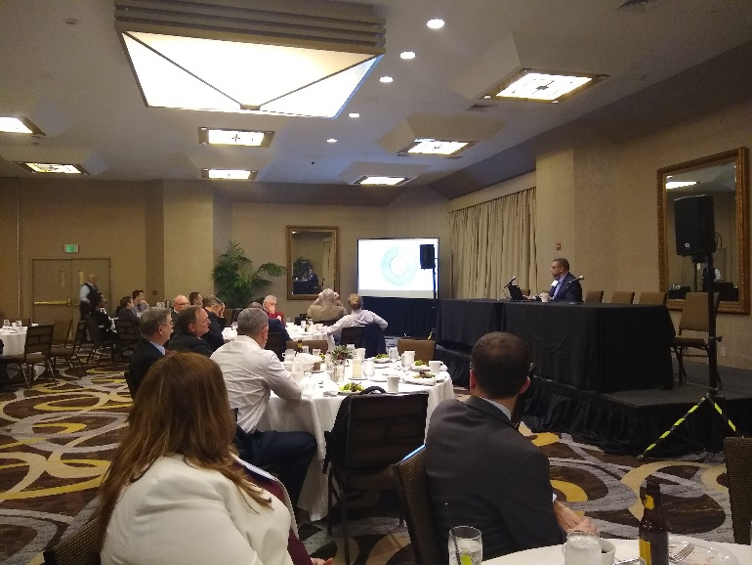

Member News? – Contact the Newsletter Editor with any news you would like to share.

About Our Next Meeting

February
TBD

2020 IIE South Jersey
Delaware Valley Senior
Chapter No. 132 Officers & Directors

Nic Le Gall
President
nic.legall@gmail.com

Carrie Weber
Vice President
(W) 215-495-7439
carrieannaweber@gmail.com
Paul Siebeneicher
Secretary, Director of Internet Communications &
Web Site Master
paulsehnen@yahoo.com
(C) 856-630-5564

Rick Huysie
Treasurer
(H) 856-931-7352

John McGowan, PE
Director of CPP Report & Engineer’s Week -
(H) 856-722-4593, (F) 856-722-7768
john.p.mcgowan@lmco.com

Kevin Drevik
Director of Communications/Newsletter and Programs
(C) 856-630-2485
KDREVIK@yahoo.com

Fred Rexon
Director of Membership
(W) 856-428-7400, (F) 856-428-1270
fredrexon@precisionautomationinc.com

Frank DeFelice
Director at Large
fd744@aol.com

Marven Chin
Director at Large
Mmchin8893@comcast.net

Career Development

IIE EVENTS & TRAINING

- January

Jan 13: Six Sigma Green Belt for Process Improvement (Norcross, GA)

Jan 13: 12: Six Sigma Green Belt for Healthcare (Norcross, GA)

Jan 22: Intro Cyber Risk in Manuf/Ind Process (Norcross, GA)

Jan 27: Methods – Time Measurement (Norcross, GA)

February

Feb 4: Six Sigma Green Belt for Process Improvement (Los Angeles, CA)

Feb 10: Lean Scrum (Norcross, GA)

Feb 25: Six Sigma Black Belt for Process Improvement (Los Angeles, CA)

Other IISE Related Events

Future Cities Competition
Saturday, Jan 18th, 8 AM – 12 PM (Volunteer time)
8 AM – 3 PM if staying for Finals
Archbishop John Carroll High School
211 Matsonford Road, Radnor PA
https://www.Futurecityphilly.org/fcvolops.html

Special Award Judge Needed!!
Chapter sponsored:
P. Robert Siebeneicher Industrial Engineering Award

MATHCOUNTS Competition
Saturday, February 1st, 8:30 AM – 12:00 PM
Rowan University
Student Center, 201 Mullica Hill Road, Glassboro NJ
https://www.mathcounts.org/south-jersey-chapter-competition
or john.p.mcgowan@lmco.com

Proctors Needed!!

CAREER CENTER

South Jersey Delaware Valley Chapter Employment Assistance Network
Are You Looking For A Job? Do You Know Of A Job Opportunity?
Contact The SJC Employment Assistance Network: Email your name or any hot opportunities to Kevin Drevik at Kdrevik@aol.com

Industrial Engineer (Plant)
Tindall Corporation - US
Plant Industrial Engineers manage a portion of the process and quality improvement processes and cost reduction activities for our large Precast/Prestress plant. https://tindallcorp.csod.com/ux/ats/careersite/2/home/requisition/209?c=tindallcorp&\=&source=Indeed

Industrial Engineer

Protocall Group – Willingsboro, NJ

Contact kdrevik@aol.com for contact info
- Operational and engineering owner of labor management systems (LMS) and related tools, reporting, and integration/interaction with other warehouse systems.
- Owner of the design, implementation and maintenance of labor tracking and reporting aspects of the WMS.
- Design, develop, implement and maintain standard operating procedures and training methods for DC associates.

Industrial Engineer (Plant)
Johns Manville – Penbryn, NJ
Responsible for equipment and work specifications; developing schedules, budgets, and forecasts; selects materials, equipment, project resources, and contractors with and ensures all aspects of the design are reviewed technically and commercially for scope, safety, quality, and functionality with guidance and support from plant engineer or divisional engineering leader..
https://www.indeed.com/viewjob?alid=57fae75ce4b04a90b34d953e&from=ja%2CiaBackPress&jk=f888da4fc44a7cf3&l=Cherry%20Hill%2C%20NJ&q=industrial%20Engineer&rgtk=1dt025s8o3dbr800&tk=1dt025s8o3dbr800&utm_campaign=job_alerts&utm_medium=email&utm_source=jobseeker_emails

Treasurer’s Report
Mr. Richard T. Huysie reports a Treasury Balance of $6,635.10 as of January 1, 2020 for the IISE South Jersey Delaware Valley Senior Chapter No. 132.

Membership Report

As of 1/1/2020 the SJDV Chapter has 55 Members.
The Boeing Company has a corporate account with IISE, which it funds straight to IISE National. They have no re-upped the Boeing members at this time, so 40 members dropped from December’s total of 95.

Please Don’t Go! Time to renew your membership
Thomas Cassidy
James Morakinyo
James Herzog
Allan Roberts
Dawn Weiss

Don’t forget to renew your IIE Membership!

Your support of your professional society is greatly appreciated. We value your Membership!

Did you know …
The IIE South Jersey Delaware Valley Chapter will reimburse 50% of Member’s Dues if he/she recruits a new full-dues paying member? Please contact the membership director prior to your associate’s joining of IIE.

Did you know …
The IIE South Jersey Delaware Valley Chapter will reimburse 50% of Member’s Dues if he/she sets up a site tour of their company’s facility for chapter members to attend? Please contact the membership or newsletter director for more information.

Check out our Chapter’s Website!!

http://paulsehnen.wixsite.com/iisesjdvpc

Quote for Today: “Anything that can be prevented, taken away, or coerced is not a person’s own – but those things that can’t be blocked are their own.’ Epictetus

IIE-SJC Newsletter Advertising Rates

Ad Size Run Length Cost Full Year
1/8 Page Single Issue $20 $100
¼ Page Single Issue $25 $250
½ Page Single Issue $75 $400
¾ Page Single Issue $75 $450
1 Page Single Issue $100 $500

Our sincere thanks to our Classified Advertisers for their strong Chapter support! Please patronize them during the year!

Kevin Drevik
Newsletter Editor
South Jersey Delaware Valley Chapter No. 132
IISE, Incorporated
20 Crider Avenue
Moorestown NJ 08057

