Theme: New Technology

Date: Tuesday, Nov 12th

Time: 5:30pm Networking

6:00pm Presentation

7:00pm Dining

Location: **Adelphia Restaurant**   
1750 Clements Bridge Rd, Deptford Township, NJ 08096

Cost: **$25.00 / Person**

RSVP Kevin Drevik

[Kdrevik@yahoo.com](mailto:Kdrevik@yahoo.com)

(856) 630-2485

**\*\* RSVP by November 11th**

______________________________



## November’s Program

# ****Joint Meeting with ASQ with Former IISE Board Member Tom Fung discussing Blockchain technology****



**Changing of the Supply Chain and Block chain**

Block chain is the technology that was created to support bitcoin transactions. The block chain technology has the potential to revolutionize the effectiveness and profitability of businesses. Our November speaker is Tom Fung, Assistant Professor at Temple and former Campbell Soup executive. Tom will give an overview on the analytical tools and business applications in operations management. Exploring how the digital economy changes the supply chain through the emerging Block chain technology platform. Tom will present three brief case studies.

**About Our Speaker**

Tom Fung is an Assistant Professor at Temple and formerly of Campbell Soup. He served as Director of Operations, managing all aspects of the supply chain, with direct impact to profit and loss. His corporate experience ranged from engineering, packaging, to operations management and strategic planning, with responsibility for 30 manufacturing plants. When the National Defense University’s Industrial College of the Armed Forces leveraged Campbell to support their Agribusiness Industry Study curriculum, Tom served as subject matter expert (SME) in food supply chain. He earned bachelor degrees in Chemistry and Chemical Engineering, an MBA, and two master’s degrees in eBusiness and Organizational Dynamics.

***President’s Message***



Greetings to the Industrial Engineering Community!

The Holiday is fast approaching! I feel that this time of year is when our profession gets to show off the year. Most companies take a year planning and executing new initiatives to help make the operations run smoothly during the busiest season of the year. Each year Cyber Monday or now, Cyber Week gets bigger and bigger. Some retailers are having their best sales the weekend before Black Friday. It is the industrial engineers analyzing ways to improve to allow the influx of big sales. So go us!

It is election season for our chapter. We do have some vacancies on the board of directors. If you are interested, please reach out. Alternatively, you could also write in for the ballot - and do not forget to Vote!

Cheers,

Carrie Weber

President of the IISE South Jersey, Delaware Valley

***CAR Article***

**The Chapter Activity Report’s Swan Song**

The swan song is a metaphorical phrase for a final gesture, effort, or performance given just before death or retirement. Recently, the IISE National informed chapter leaders that as IISE continues to strive towards excellence in our operations and services to its members, it requires all of us to look at areas where we can continually improve our services. The IISE National says it recognizes that completing the CAR / UCAR documents is often considered more of a chore as opposed to a thought-provoking recap on accomplishments and plans. In addition, they will only ask us to provide those metrics that we feel add value.

In a few weeks, IISE will post the new reporting forms for both Professional and University Chapters, which we are encouraged to download immediately and start using them to guide our Chapter in focusing on the same issues IISE values as most important.

That is a pretty speech; so much truth and awareness. If truth were told, the Chapter Activity Report did get outdated. Chapters were reporting on things they had little or no say in – how much money did we donate to IISE National/scholarships; and membership growth was more dependent on what/where the National Conference was about. Our chapter always did well in the same areas and saw little improvement in the areas we did not do so well. Still one would think that an improvement in chapter reporting might include input by the chapters. Cannot wait to see the new forms!

We still encourage you to share your accomplishments (promotions, speaking engagements, published articles, etc.). We do have one of the more active chapters; as demonstrated but not defined by 20 consecutive gold chapter awards. In addition, we have a most promising program this month on Block chain & the Supply Chain. Tom Fung is a great speaker and really provides some good insights. I hope to see you there!

Just as a preemptive PS – I probably did miss the survey!



***MEMBER NEWS***

**Event Report**

**On October 19th, our chapter president joined Joseph Wagner in holy Matrimony. They chose to go with family and friends and have the event in Las Vegas! They did the wedding and the honeymoon together?**

**Despite some rumors, they did not get married by Elvis (They couldn’t afford the real Elvis, so they went with an Elvis impersonator?). A good time was had by all, so let’s salute our president when next you see her – and ask her about the ring.**

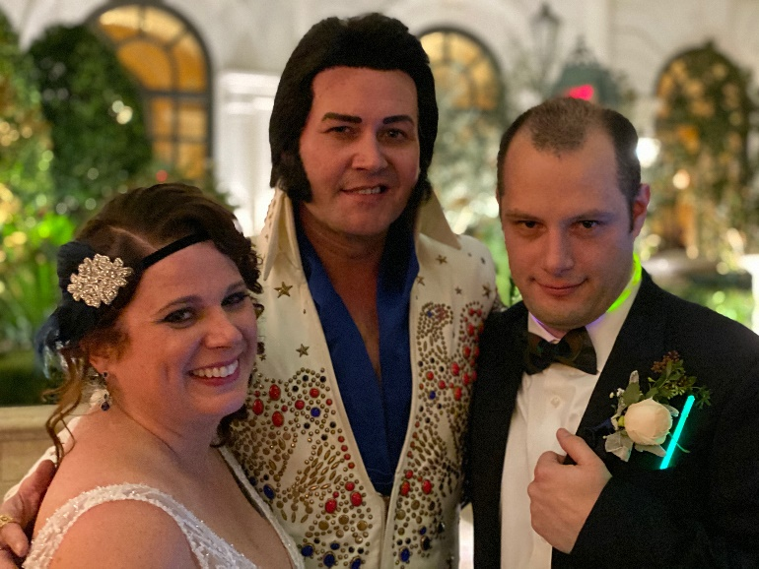

**Member News? – Contact the Newsletter Editor with any news you would like to share.**

**About Our Next Meeting**

**Tuesday, Dec 10th @5:30pm**

**Engineer’s Club of Philadelphia**

**Multi-society event**

**Sponsor: Christopher Holiday**

**2019 IIE South Jersey**

**Delaware Valley Senior**

**Chapter No. 132 Officers & Directors**

**Carrie Weber**

President

(W) 215-495-7439

[carrieannaweber@gmail.com](mailto:carrieannaweber@gmail.com)

**Nic Le Gall**

Vice President

[nic.legall@gmail.com](mailto:nic.legall@gmail.com)

**Paul Siebeneicher**

Secretary, Director of Internet Communications &

Web Site Master

[paulsehnen@yahoo.com](mailto:paulsehnen@yahoo.com)

(C) 856-630-5564

**Rick Huysie**

Treasurer

(H) 856-931-7352

**John McGowan, PE**

Director of CAR & Engineer’s Week -

(H) 856-722-4593, (F) 856-722-7768

[john.p.mcgowan@lmco.com](mailto:john.p.mcgowan@lmco.com)

**Kevin Drevik**

Director of Communications/Newsletter and Programs

(C) 856-630-2485

[KDREVIK@yahoo.com](mailto:KDREVIK@yahoo.com)

**Fred Rexon**

Director of Membership, Director of Community Affairs & PR

(W) 856-428-7400, (F) 856-428-1270

[fredrexon@precisionautomationinc.com](mailto:conkr@aol.com)

**Frank DeFelice**

Director & Master of Arms

[fd744@aol.com](mailto:fd744@aol.com)

**Marven Chin**

Director at Large

[Mmchin8893@comcast.net](mailto:Mmchin8893@comcast.net)

|  |  |  |  |  |  |  |  |  |  |  |  |  |  |  |  |  |  |  |  |  |
| --- | --- | --- | --- | --- | --- | --- | --- | --- | --- | --- | --- | --- | --- | --- | --- | --- | --- | --- | --- | --- |
| Career Development  **IIE EVENTS & TRAINING**  **Webinars (check out IISE.org for free webinar training)**   * **Oct 1: How to Create Value in “Covert” ISE Roles (12pm EST)** * **November**   Nov 4: Introduction to Engineering Analytics (Norcross, GA)  Nov 5: Lean Green Belt (USC – Los Angeles, CA)  Nov 6: Advanced Engineering Analytics (Norcross, GA)  Nov 12: Six Sigma Green Belt for Process Improvement (Los Angeles, CA)  Nov 12: Six Sigma Green Belt for Process Improvement (Norcross, GA)  Nov 12: Six Sigma Green Belt for Healthcare (Norcross, GA)  Nov 19: Lean Scrum (Norcross, GA)  **December**  Dec 11: Facilities and Workplace Design – Norcross, GA  Dec 11: Six Sigma Green Belt for Process Improvement (Norcross, GA)  Dec 11: Six Sigma Green Belt for Healthcare (Norcross, GA)  [http://ih.constantcontact.com/fs192/1101700049774/img/2051.jpg](http://r20.rs6.net/tn.jsp?f=001LdEjUCJ6pmw2YGSQshWRH_H-3U4NciV9Jyd202zfRWF4HbViAO5W50HAKq63T3A5ybOO_1KMqIqupjOmq9OLJra1stsOZJpSrGrZnnMbrZja0D1OcJOOje0yovE4zeaWFA_1LyNZKUXB_FeNEw7F0z2S2X0ph_0DNOc_y-xmuORC0mhpzde9bywYDzTeP_GQon_ZNAImqeU=&c=RgHAAFVn8uQFB9d6jEkXLSr8yhSJzaF-Wz9t1aGnFp1SCIyHY5cEAA==&ch=WGdmLd5HrMyNky3tnMVfWT6Himw7fPm2Vcvi0lSAVDtCULLz124bLw==)  ***CAREER CENTER*** South Jersey Delaware Valley Chapter Employment Assistance Network Are You Looking For A Job? Do You Know Of A Job Opportunity?  Contact The SJC Employment Assistance Network: Email your name or any hot opportunities to Kevin Drevik at **Kdrevik@aol.com**  **Industrial Engineer I**  Burlington Stores, Edgewater Park, NJ  [NFI Industries](https://www.indeed.com/cmp/Nfi?campaignid=mobvjcmp&from=mobviewjob&tk=1dlk6osoh5m8h800&fromjk=16f60ca7cf893f49)  Kutztown, PA 19530  Bring your skills as an **Industrial Engineer, Level I** to a growing Fortune 500 retail company and certified Great Place to Work! As an **Industrial Engineer** on our growing supply chain team, you will help to improve processes and productivity by providing changes to operations, work measurements, methods, materials usage, and training  **Industrial Engineer 2**  Boeing, Ridley Park PA   * Investigates and develops complex equipment and tooling concepts and specifications to satisfy aerospace product design and build requirements. * Participates in design reviews, collects design requirements, creates and revises drawings and models, researches the application of robotics, automation and new technology to support the build plan. Creates off-load packages, specifications, purchase requests and usage instructions for equipment and tooling. * Checks designs for compliance with safety, producibility, maintainability, reliability, ergonomic factors and regulatory requirements.   **Industrial Engineer**  ComTec Consultants - Philadelphia, PA   * Performs research, design and development of manufacturing processes, including production flow, assembly methods and production equipment. * Prepares and maintains detailed layouts of buildings and equipment * Coordinates the manufacturing launch of new/revised products, including establishing goals, training team members and evaluating results.  |  | | --- | | ***Treasurer’s Report***  j0245293***Mr. Richard T. Huysie reports a Treasury Balance of $6,782.39 as of October 30th, 2019 for the IISE South Jersey Delaware Valley Senior Chapter No. 132.*** |   ***Membership Report***  As of 10/1/2019 the SJDV Chapter has **108** Members.  **Please Don’t Go!**  **Time to renew your membership**   |  |  |  |  | | --- | --- | --- | --- | |  |  | |  | | Kevin Drevik  Kelly Larson | | |  | | | Jose Vasquez  Adam Schiowitz | | |  | | |  | | |  | | |

**Don’t forget to renew your IIE Membership!**

**Your support of your professional society is greatly appreciated. We value your Membership!**

|  |
| --- |
| **Did you know …**  **The IIE South Jersey Delaware Valley Chapter will reimburse 50% of Member’s Dues if he/she recruits a new full-dues paying member? Please contact the membership director prior to your associate’s joining of IIE.** |

**Check out our Chapter’s Website!!**

[**http://paulsehnen.wixsite.com/iisesjdvpc**](http://paulsehnen.wixsite.com/iisesjdvpc)

**Quote for Today**: “Don’t trust in your reputation, money or position, but in the strength that I syours – namely, your judgements about the things that you control and don’t control. For this alone is what makes us free and unfettered, that picks us up by the neck ffrom the depths and lifts us eye to eye with the rich and powerful.”

*Epictetus, Discourses, 3.26.34-35*

|  |  |
| --- | --- |
|  |  |

**IIE-SJC Newsletter Advertising Rates**

Ad Size Run Length Cost Full Year

1/8 Page Single Issue $20 $100

¼ Page Single Issue $25 $250

½ Page Single Issue $75 $400

¾ Page Single Issue $75 $450

1 Page Single Issue $100 $500

***Our sincere thanks to our Classified Advertisers for their strong Chapter support! Please patronize them during the year!***



Kevin Drevik

Newsletter Editor

South Jersey Delaware Valley Chapter No. 132

IISE, Incorporated

20 Crider Avenue

Moorestown NJ 08057

