Theme: Quality Roundtable

Date: Wed., February 12th

Time: 5:30pm Networking
6:00pm Presentation
7:00pm Dining

Location: Adelphia Restaurant
1750 Clements Bridge Rd, Deptford Township, NJ 08096

Cost: $25.00 / Person

RSVP Sharry Masarek
smasarek@sections.asq.org

______________________________
Chapter members are invited to set up a site tour of their employer’s facility for the chapter’s membership, in exchange for half off membership dues for a year. The tour ideally should include at least one topic of interest to IISEs, examples automation, just-in-time, lean, logistics, etc. The brief proposal should include the name of the employer, the location of the facility, the approximate size of the facility, a sentence or two about the focus of the proposed tour, any date or time suggestions and/or restrictions for the tour, and contact information for a contact person who can arrange such tour.

February’s Program

Joint Meeting with ASQ: Quality Circle

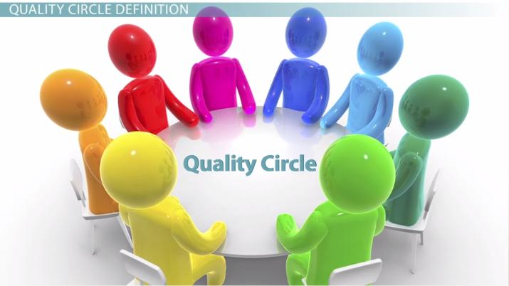

ASQ and IISE will be conducting a quality circle for their February meeting. Various questions will be discussed in reference to building a quality program in your organization, maintaining the quality program, and dealing with numerous issues in response to challenges in this highly competitive environment. Join us!
President’s Message

Hello all!
Having just graduated and being in the process of job hunting has made me stop and think: what do Industrial Engineers do? How do we describe our field to those who are not familiar with it? In our chapter alone, we have members working in automation, supply chain, manufacturing, and aerospace among others. Some of my classmates at Rutgers now work in the financial sector, building machine learning models, in the energy sector, or construction.
Talking about my studies to those not familiar with our field made me think about how broad it can be. With possibilities as broad encompassing ergonomics, reliability, data science, logistics (to name a few), it was hard to know where to start to describe what I was studying! However, I do find some sense of pride in knowing that our field gives us a good range of options, and feel that it may be in part due to our training that allows us to problem solve efficiently.
In the scope of our chapter’s aim to recruit new members, is the default definition that we are using limiting our approach? When we think about how different the actual job descriptions can be, are there potential members that we aren’t reaching out to?
I’d love for us to start having a conversation about what we as a chapter consider industrial engineering to be and whether or not we should be re-examining that definition.
Best regards,
Nicolas Le Gall – President, IISE Chapter 132

CAR Article

CAR Article
25 Years of Growing Engineers (And Other Great People)!
The 25th annual Philadelphia Regional Future City Competition was held on January 18, 2020 at Archbishop Carroll High School in Radnor, PA. Forty-four schools participated in the event which was won by Lionville Middle School from Exton, Pa.; which will compete at the national competition in Washington, DC scheduled for February 15th-19th. This year’s theme centered on procuring & protecting water resources. Over 600 students participated in this year’s competition.
The Final Results:

1st Place Lionville MS
2nd Place Downingtown MS
3rd Place Queen of Angels

Honorable Mention St. Andrew School
Honorable Mention St. Cecilia
Honorable Mention St. Hilary of Poitiers

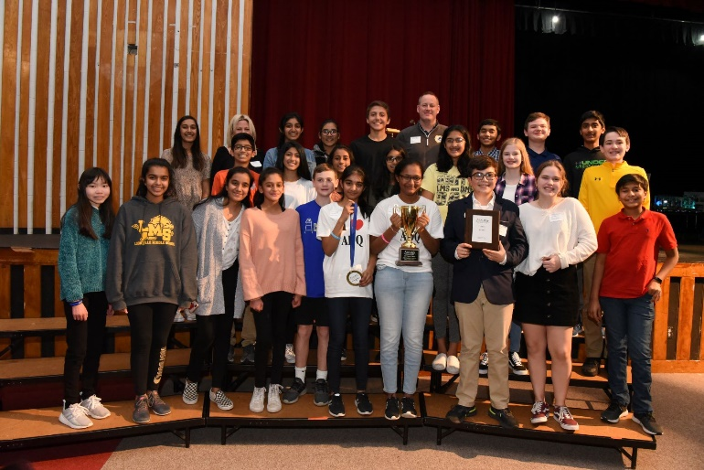
Lionville Middle School Team
The Future City Competition is directed toward 6th, 7th, and 8th grade students and is intended to expose and encourage students to STEM (science, technology, engineering, and math) careers. Students got a varied experience with creating their cities with simulation software, creating physical models/representations of the cities, writing essays, and presenting their findings before teams of practices engineers.
Chapter member John McGowan; who has volunteered since the 1998 competition served as a presentation & model judge. “I got to do the preliminary judging for eventual winner Lionville M.S. and they were the sharpest team I ever judged. Their presentation was exactly 7 minutes, crisp, entertaining, and well thoughtout. Their model was also top notch. I expect them to do very well at the national competition.”
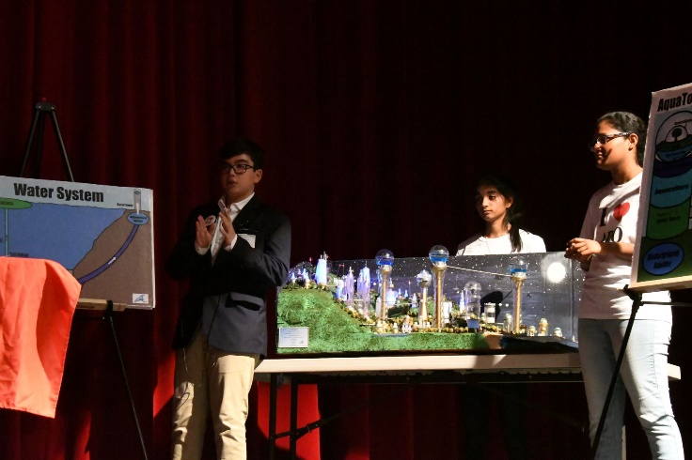
Lionville Presentation at the Final Judging
The Chapter made a $300 contribution and sponsored the P. Robert Siebeneicher II Industrial Engineering Award which was won by St. Andrews Newtown. Bob Siebeneicher; who was a long time leader of the Chapter and the IISE; was the chapters only IISE Fellow. He was a strong proponent and champion of career development and education. He also served as a long time Future City judge.
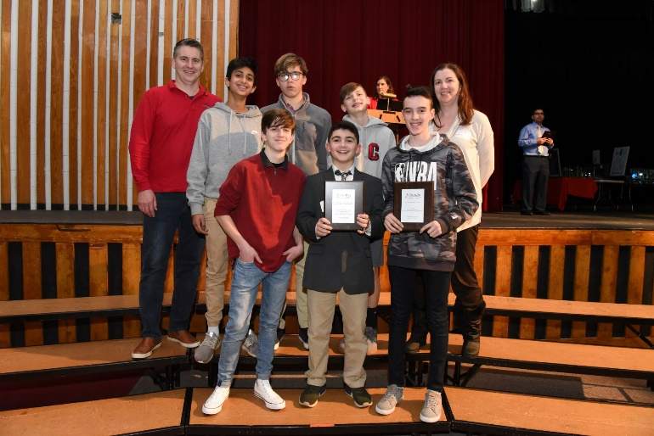
St. Andrews Newtown – Winners of IISE Chapter Award

The purpose of the competition is to introduce middle school students to STEM education and careers. The students reported learning about the many different types of engineering professions. When a 3-student team was asked what they learned about engineering from Future City exercises a full gambit was expressd from one student who didn’t like science and math and participated to push herself to the student who knew he wanted to be an engineer.
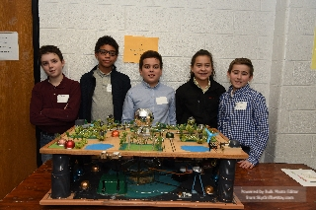
Maria Kaupas Academy – One of 41 Participating Schools
There were 54 special awards sponsored by various companies, professional organizations, and individuals. Each special award carries its own criteria – from most innovative use of materials, creative transportation methods, energy usage, etc. The Chapter’s sponsored P. Robert Siebeneicher Industrial Engineering Aard was won by St. Andrews Newtown in Newtown, Pa.
As a long-time volunteer for student competitions; I want to convey the sense of joy and pride I get from seeing them take on the challenges that these competitions promise. The level of output varied greatly between schools as some schools treat the competition as an activity of the classroom learning experience; while others treat it as an after-school volunteer activity. Some schools have been paricipating for the whole 25 years (and learning/benchmarking during that time); while others paricipated for the first or second time. But despite the level of experience or knowledge already gained; one could readily see that each student was pushing themselves beyound a comfort level and succeeding. When I questioned one of the newer teams in the competition about what they learned or enjoyed most about their experience; they admiitted much of the Future City criteria was not their strenghth; they preferred coding.
This year I noticed the use of 3D printed parts in models – what are they teaching these kids! They were given a problem to consider (water prcurement and protection); they researched solutions and addressed them with a simulation model, physical model representation, essay, and each team (3 members of team) presented their findings. Middle schoolers presenting to groups of engineers; this HAD to be beyound some comfort zones and I found them to be AMAZING!!!!!!
I have said it before and believe it even moreso after this most resent competition; the future of engineering is very bright. - JPM

MORE ON FUTURE CITY
The mission of the DiscoverE Future City Competition is to provide a fun and exciting educational engineering program for middle school students that combines a stimulating engineering challenge with a "hands-on" application to present their vision of a city of the future.
The Philadelphia Regional Future City Competition is a 501.c.3 educational outreach program of DiscoverE. We are one of 39 regional programs conducted throughout the country with the goal to introduce middle school students to the engineering profession. The Future City Program continues to be on the National Association of Secondary School Principals' National Advisory List of Student Contests and Activities.
The Philadelphia Regional Competition draws schools from Philadelphia and surrounding counties including the Lehigh Valley, Southern New Jersey and Delaware. Students from middle schools and after school programs in the region form teams consisting of 6th, 7th, and 8th grade students who work with a teacher and an engineer mentor from September to January.
Note: The 2019 MATHCOUNTS competition will at Rowan University on Saturday, Feb 1.

CHAPTER NEWS

Event Report

On January 16th the chapter joined the local ASQ (American Society of Quality) for their monthly dinner meeting in Deptford, NJ.

Dennis Palmer, Chief Engineer of Landis Sewage Authority in Vineland, presented on his operation and their work towards their green initiatives. The topics included their use of wind/solar (they have a large solar farm), how they clean the waste water, and re-use parts of it for fertilizer for local farming options. They also are involved in managing 600 acres of forest (controlled burns, replanting, etc.). Overall, the site is a net generator of over 1.5 Megawatts of power for the local community, while maintaining top grade water reprocessing. An excellent example of what can be done with the right amount of effort, a long-range plan, and the time to do it. Excellent presentation and some good food!

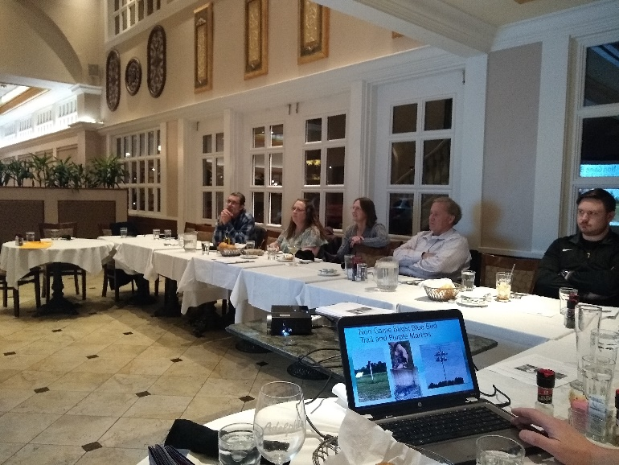

Member News? – Contact the Newsletter Editor with any news you would like to share.

About Our Next Meeting

March
TBD

2020 IIE South Jersey
Delaware Valley Senior
Chapter No. 132 Officers & Directors

Nic Le Gall
President
nic.legall@gmail.com

Carrie Weber
Vice President
(W) 215-495-7439
carrieannaweber@gmail.com
Paul Siebeneicher
Secretary, Director of Internet Communications &
Web Site Master
paulsehnen@yahoo.com
(C) 856-630-5564

Rick Huysie
Treasurer
(H) 856-931-7352

John McGowan, PE
Director of CPP Report & Engineer’s Week -
(H) 856-722-4593, (F) 856-722-7768
john.p.mcgowan@lmco.com

Kevin Drevik
Director of Communications/Newsletter and Programs
(C) 856-630-2485
KDREVIK@yahoo.com

Fred Rexon
Director of Membership
(W) 856-428-7400, (F) 856-428-1270
fredrexon@precisionautomationinc.com

Frank DeFelice
Director at Large
fd744@aol.com

Marven Chin
Director at Large
Mmchin8893@comcast.net

Career Development

IIE EVENTS & TRAINING

- February

Feb 4: Six Sigma Green Belt for Process Improvement (Los Angeles, CA)

Feb 10: Lean Scrum (Norcross, GA)

Feb 18: Six Sigma Black Belt for Process Improvement (Los Angeles, CA)

- March

Mar 2: Six Sigma Black Belt (Norcross, GA)

Mar 2: Six Sigma Black Belt for Healthcare (Norcross, GA)

Mar 16: Lean Green Belt (Norcross, GA)

Mar 16: Lean Green Belt for Healthcare (Norcross, GA)

Mar 17: Six Sigma Black Belt for Process Improvement (Los Angeles, CA)

Other IISE Related Events

MATHCOUNTS Competition
Saturday, February 1st, 8:30 AM – 12:00 PM
Rowan University
Student Center, 201 Mullica Hill Road, Glassboro NJ
https://www.mathcounts.org/south-jersey-chapter-competition
or john.p.mcgowan@lmco.com

Proctors Needed!!

CAREER CENTER

South Jersey Delaware Valley Chapter Employment Assistance Network
Are You Looking For A Job? Do You Know Of A Job Opportunity?
Contact The SJC Employment Assistance Network: Email your name or any hot opportunities to Kevin Drevik at Kdrevik@aol.com

Industrial Engineer
US Cold Storage – Camden NJ
The industrial engineer will assume the responsibility for developing engineered labor standards for the LMS (Labor Management System) This individual will be responsible for conducting work measurement studies in the warehouses, developing labor standards for employees, and implementing efficient distribution and order fulfillment process improvements. https://careers-uscold.icims.com/jobs/1778

Industrial Engineer

Agusta Westland – Philadelphia, PA

Applies basic Industrial Engineering concepts, techniques, analysis and decision tools to promote and implement changes in manufacturing, engineering and service operations. Develops models, data bases and spreadsheets to analyze data and provide summary analysis and metrics as directed by higher level employees for consultation to customers. https://workforcenow.adp.com/mascsr/default/mdf/recruitment/recruitment.html?cid=070b2b3d-d077-4d73-b340-6055055056a6&ccId=19000101_000001&jobId=329863&source=IN&lang=en_US

Engineer – store Fixture Industry

KRG Enterprises – Philadelphia, PA
We are currently seeking experienced candidates to join our innovative Store Fixture/POP display engineering team. We are a turn-key supplier of custom retail fixtures, store environments, food service and architectural millwork located in Philadelphia, PA.
Contact Kevin Drevik@kdrevik@aol.com for link to job posting

Treasurer’s Report
Mr. Richard T. Huysie reports a Treasury Balance of $6,524.13 as of January 29, 2020 for the IISE South Jersey Delaware Valley Senior Chapter No. 132.

Membership Report

As of 1/29/2020 the SJDV Chapter has 55 Members.
The Boeing Company has a corporate account with IISE, which it funds straight to IISE National. They have no re-upped the Boeing members at this time, so 40 members dropped from December’s total of 95.

Please Don’t Go! Time to renew your membership
Thomas Cassidy
James Morakinyo
James Herzog
Allan Roberts
Dawn Weiss

Don’t forget to renew your IIE Membership!

Your support of your professional society is greatly appreciated. We value your Membership!

Did you know …
The IIE South Jersey Delaware Valley Chapter will reimburse 50% of Member’s Dues if he/she recruits a new full-dues paying member? Please contact the membership director prior to your associate’s joining of IIE.

Did you know …
The IIE South Jersey Delaware Valley Chapter will reimburse 50% of Member’s Dues if he/she sets up a site tour of their company’s facility for chapter members to attend? Please contact the membership or newsletter director for more information.

Check out our Chapter’s Website!!

http://paulsehnen.wixsite.com/iisesjdvpc

Quote for Today: “If you wish to improve, be content to appear clueless or stupid in extraneous matters – don’t wish to seem knowledgeable. And if some regard you as important, distrust yourself.” Epictetus

IIE-SJC Newsletter Advertising Rates

Ad Size Run Length Cost Full Year
1/8 Page Single Issue $20 $100
¼ Page Single Issue $25 $250
½ Page Single Issue $75 $400
¾ Page Single Issue $75 $450
1 Page Single Issue $100 $500

Our sincere thanks to our Classified Advertisers for their strong Chapter support! Please patronize them during the year!

Kevin Drevik
Newsletter Editor
South Jersey Delaware Valley Chapter No. 132
IISE, Incorporated
20 Crider Avenue
Moorestown NJ 08057

